**Task 4 Given By Mr. Vimal Daga Sir**

Face Recognition Using Transfer Learning

Transfer Learning Python

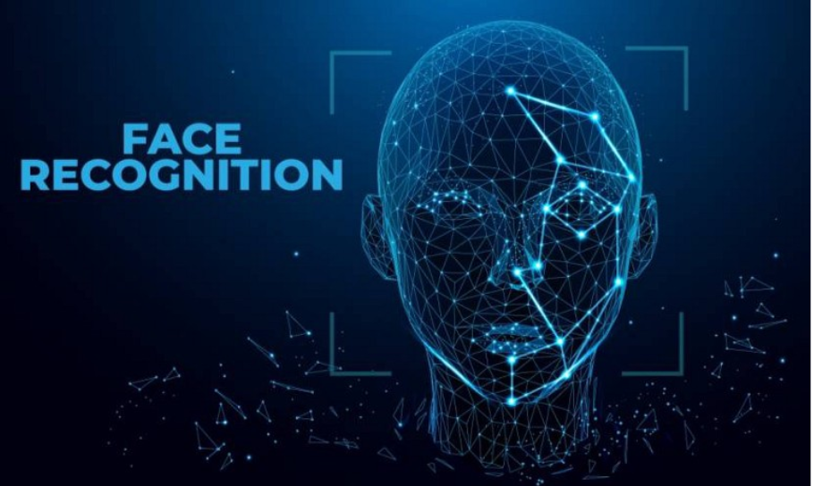

**Task Description :-**

Task-4  
Problem Statement: Create a project using transfer learning solving various problems like Face Recognition, Image Classification, using existing Deep Learning models like VGG16, VGG19, ResNet, etc.

**WhaT is Transfer Learning ?**

**Transfer learning (TL)** is a research problem in [machine learning](https://en.wikipedia.org/wiki/Machine_learning" \o "Machine learning) (ML) that focuses on storing knowledge gained while solving one problem and applying it to a different but related problem.[[1]](https://en.wikipedia.org/wiki/Transfer_learning" \l "cite_note-1) For example, knowledge gained while learning to [recognize](https://en.wikipedia.org/wiki/Computer_vision" \l "Recognition" \o "Computer vision) cars could apply when trying to recognize trucks. This area of research bears some relation to the long history of psychological literature on [transfer of learning](https://en.wikipedia.org/wiki/Transfer_of_learning" \o "Transfer of learning), although formal ties between the two fields are limited. From the practical standpoint, reusing or transferring information from previously learned tasks for the learning of new tasks has the potential to significantly improve the sample efficiency of a reinforcement learning agent

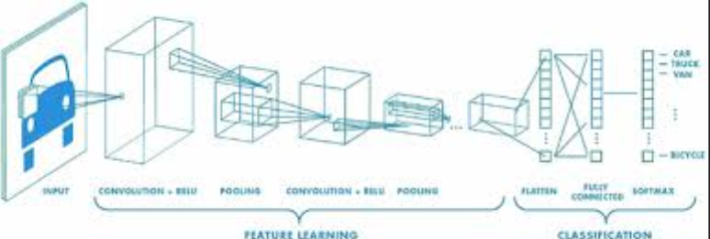

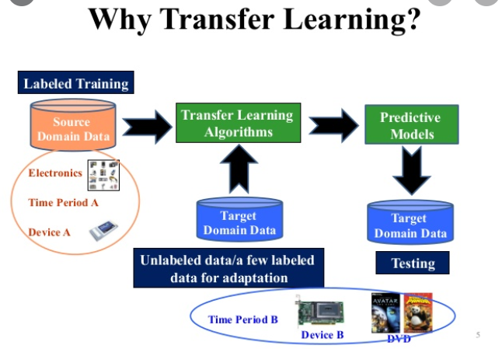

sO Lets Start with Task :-

This is First Code need FOr Our Task so in this task I have created 3 files and in every files they have theoir own code sooo lets start with 1st One .

1. Capture\_Image\_Collect\_Sample - This is my First File that will Capture Images and store them in given directory e.g. as in my case I created 2 folders as **Abhi** And **Anshu** And in BoTh of this 2 Folders I have stored 100 - 100 images by using this file or program **Capture\_Image\_Collect\_Sample.ipynb**

sO I am Sharing here the Code for above steps so that u can understand well and for performing this task we need some modules of python to be installed in conda environment like Keras, Tensorflow, cv2, NumPy etc.

sO I am sharing that steps also where I have installed this modules and I am launching jupyter notebook on that environment only .

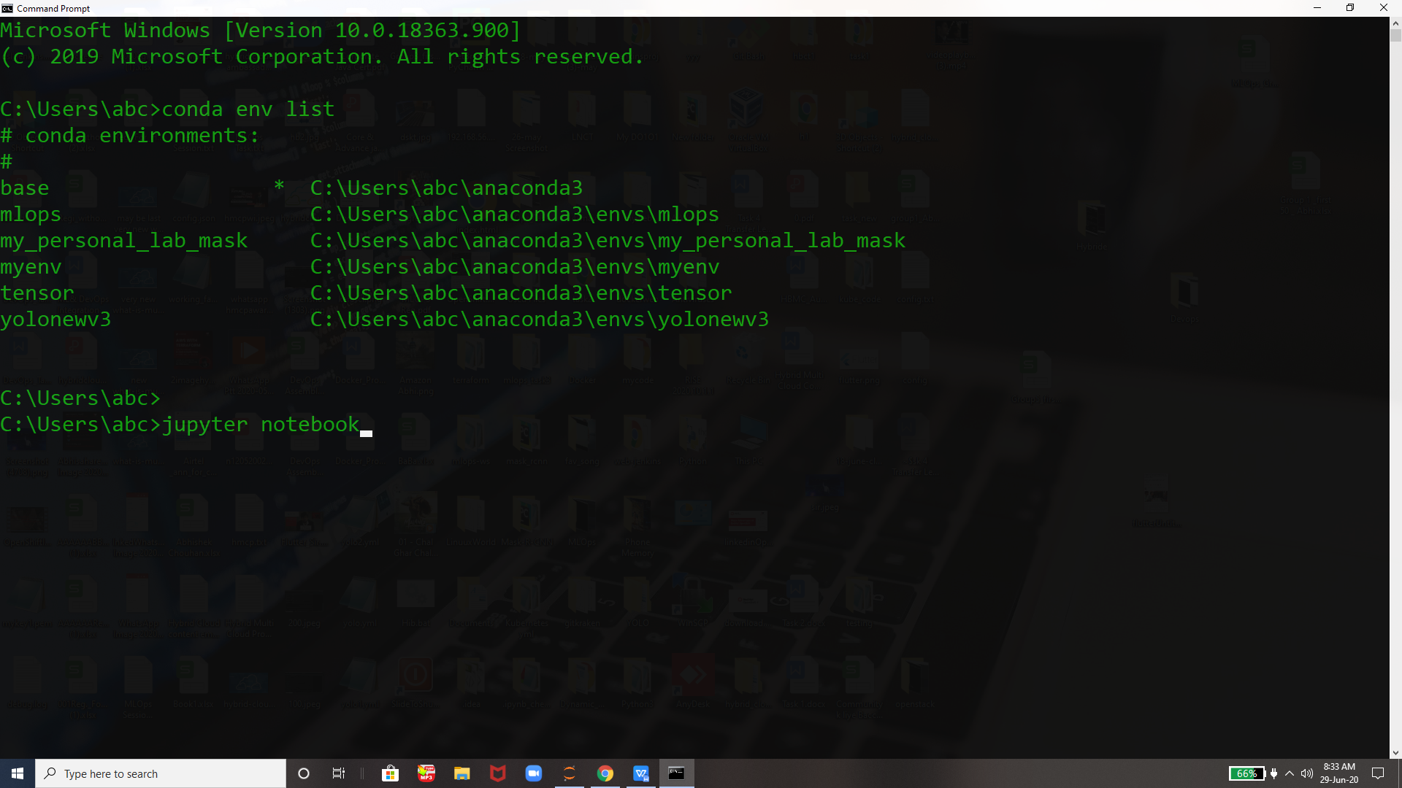

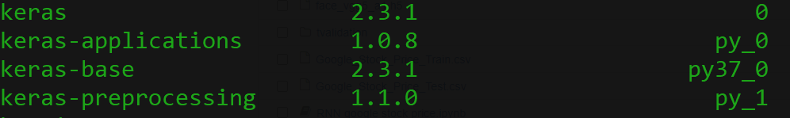



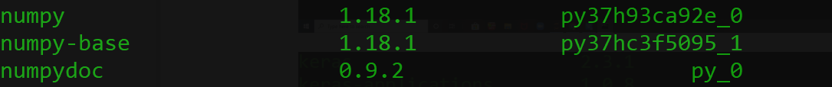

And some more we need as mentioned above .

Now Above jupyter command will launch jupyter notebook-

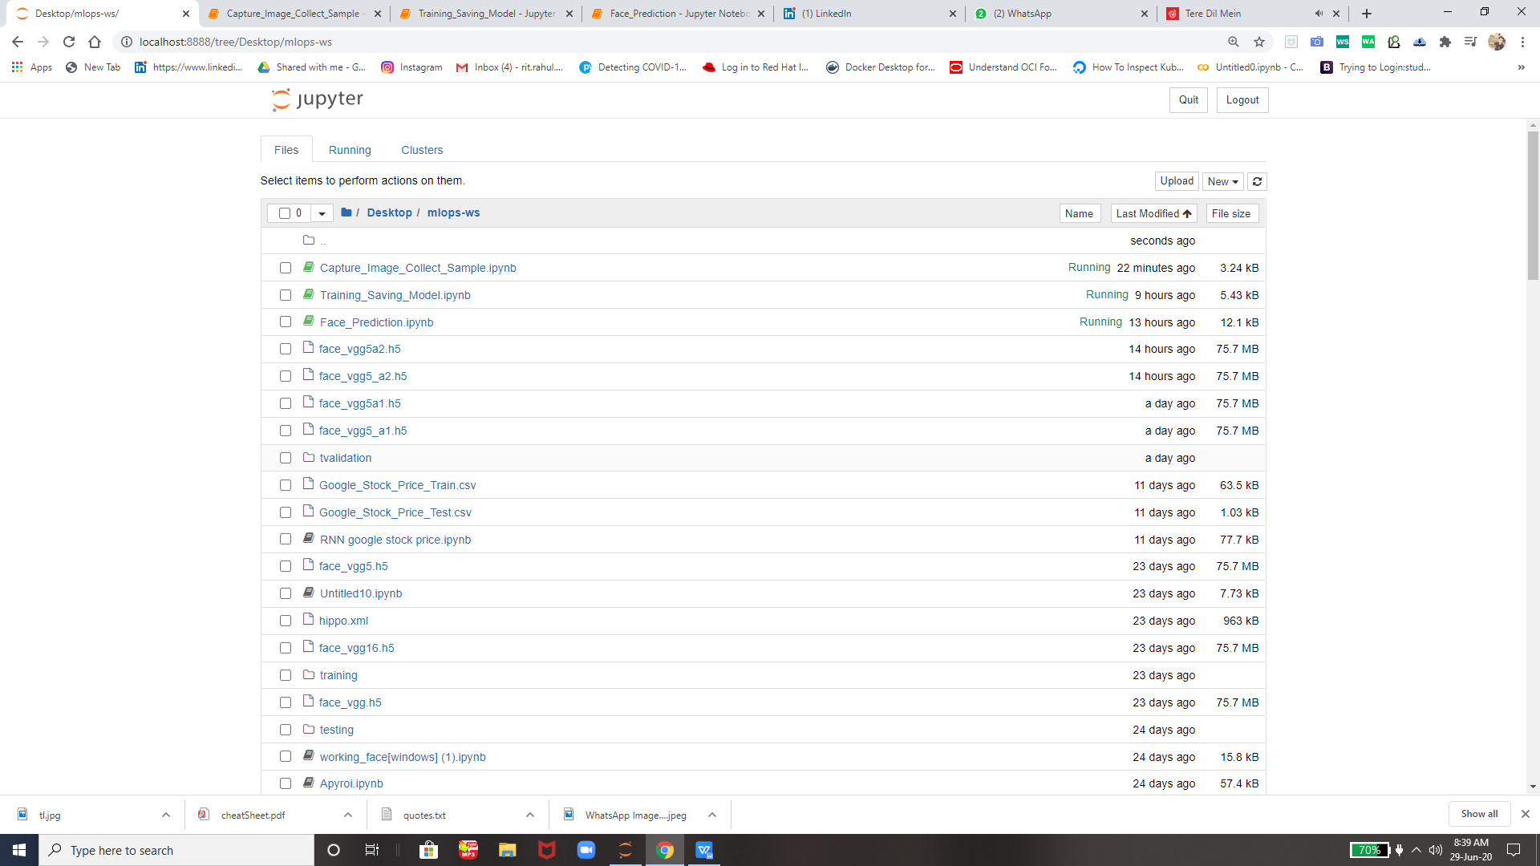

So we have 3 files as mentioned above

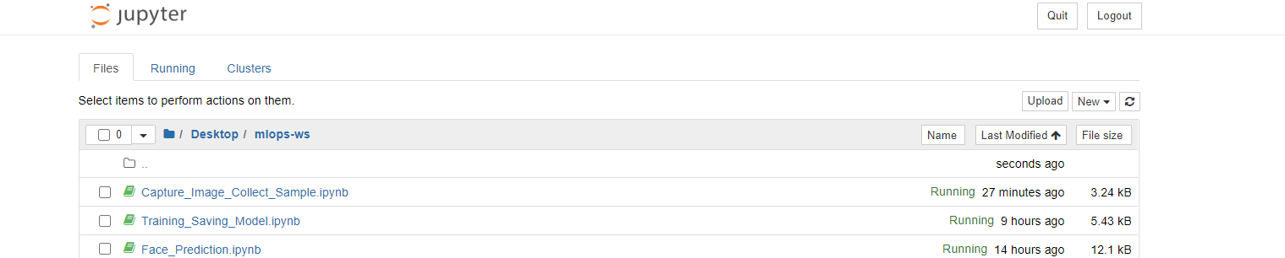i am starting from 1st one i.e. **Capture\_Image\_Collect\_Sample.ipynb**

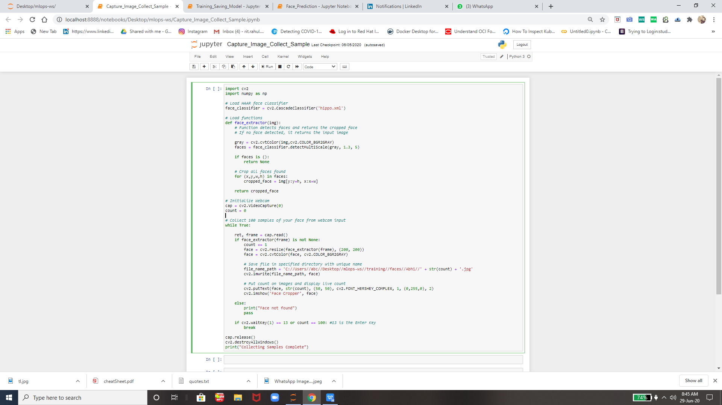



And save them in respective folder according to our requirement as created 2 folder 1st is Training and 2nd is Testing inside 1st one their is subfolder faces and inside faces their are 2 subfolders as Abhi and Anshu and inside these folders I have kept my images clicked by this above program and then we can see 100 - 100 images will be there and then as I explained I have created one more folder as Testing so I will keep 20% images of these folders inside testing folder respectively so that our model can train and can also test the images after this so I am showing that part also

1. **Training\_Saving\_Model.ipynb -** This File will train the model using this images stored and Abhi and Anshu Folders Respectively and after this will create one wait and save it as in my case I gave it a name as **vgg5a2.h5**

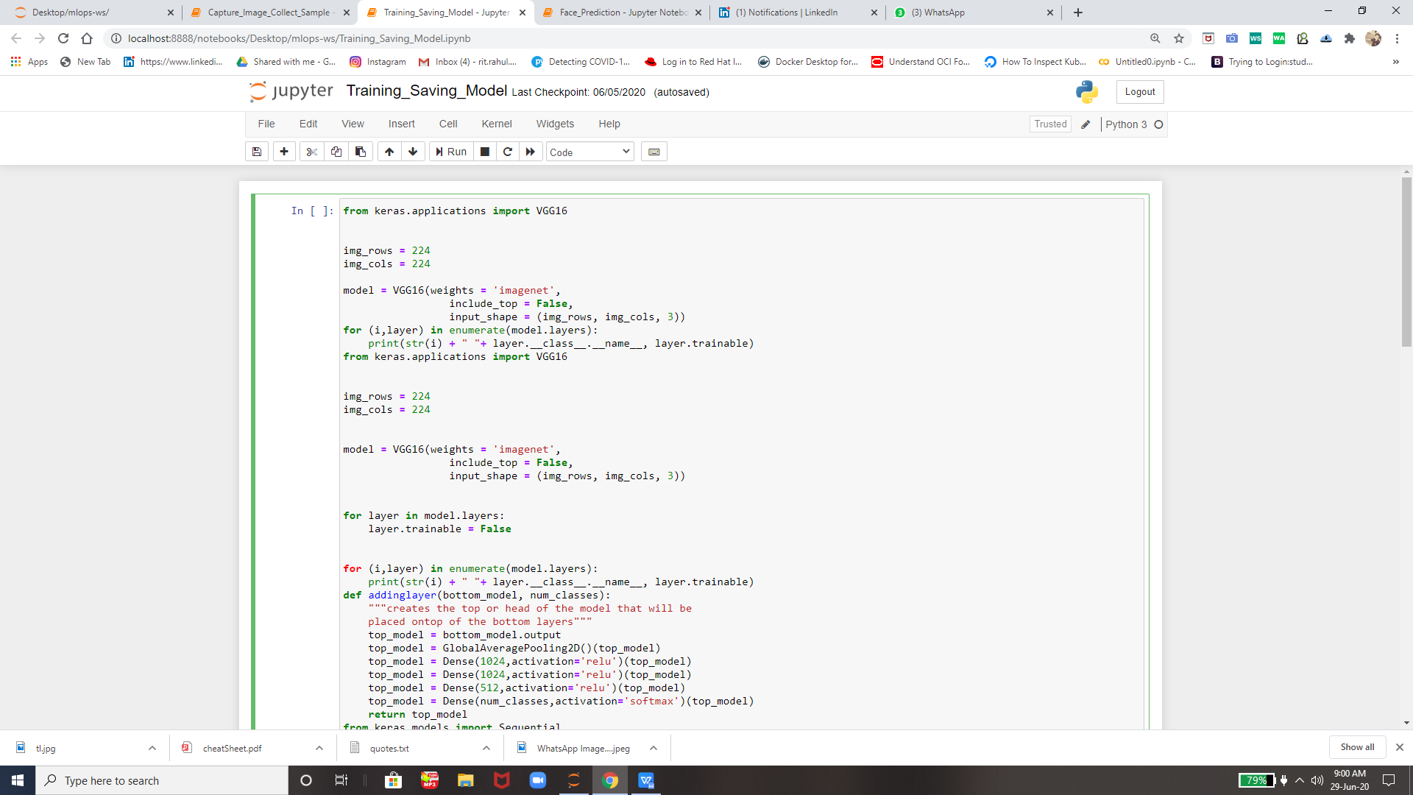

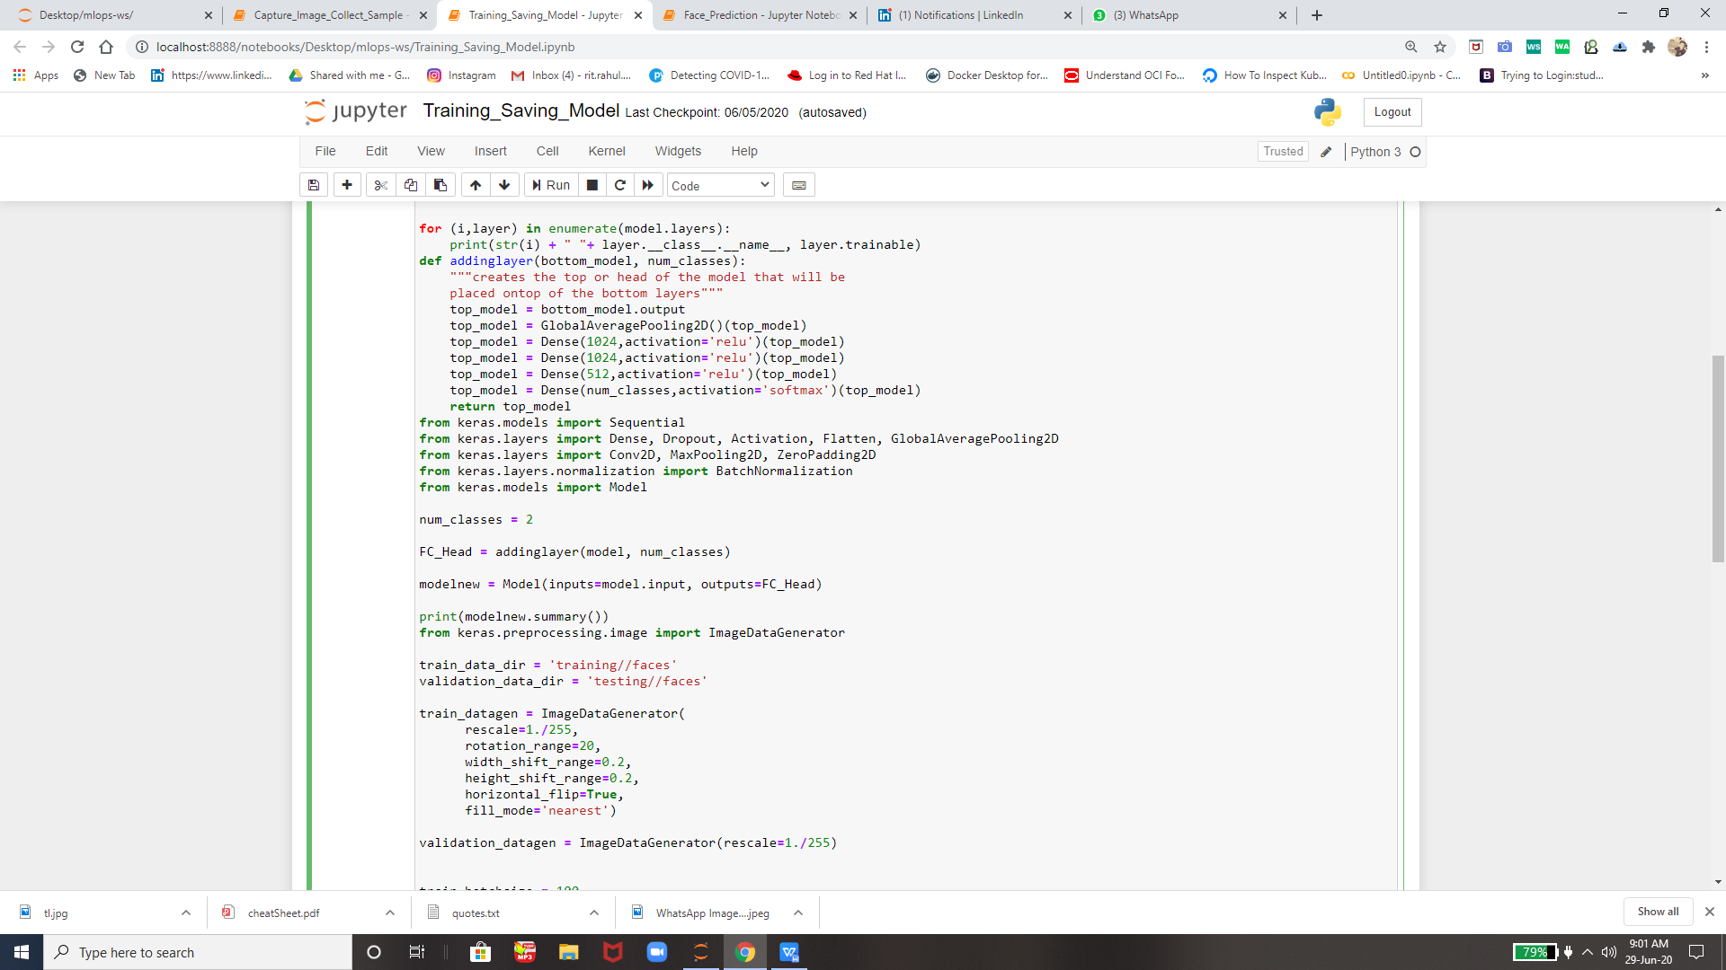

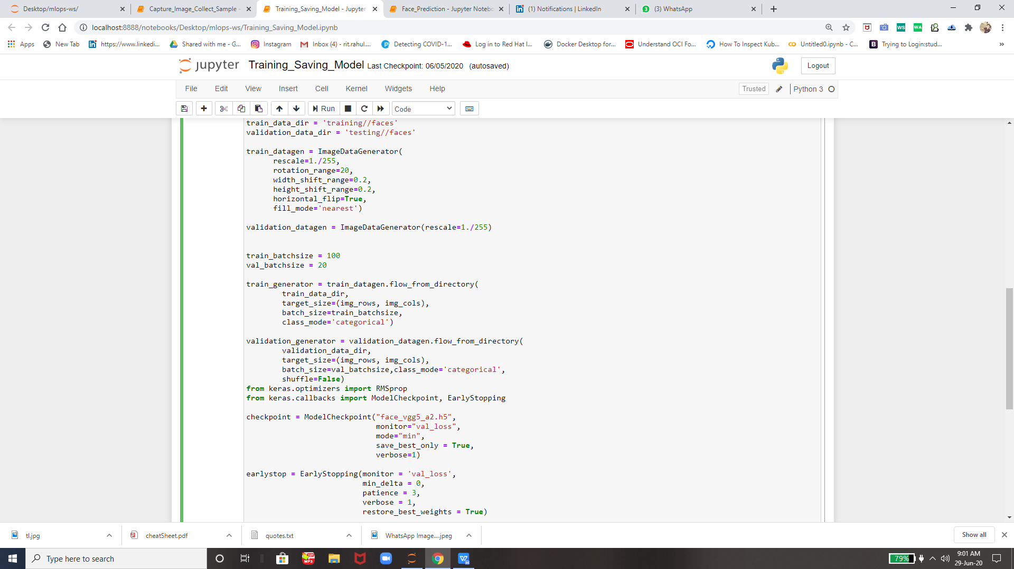

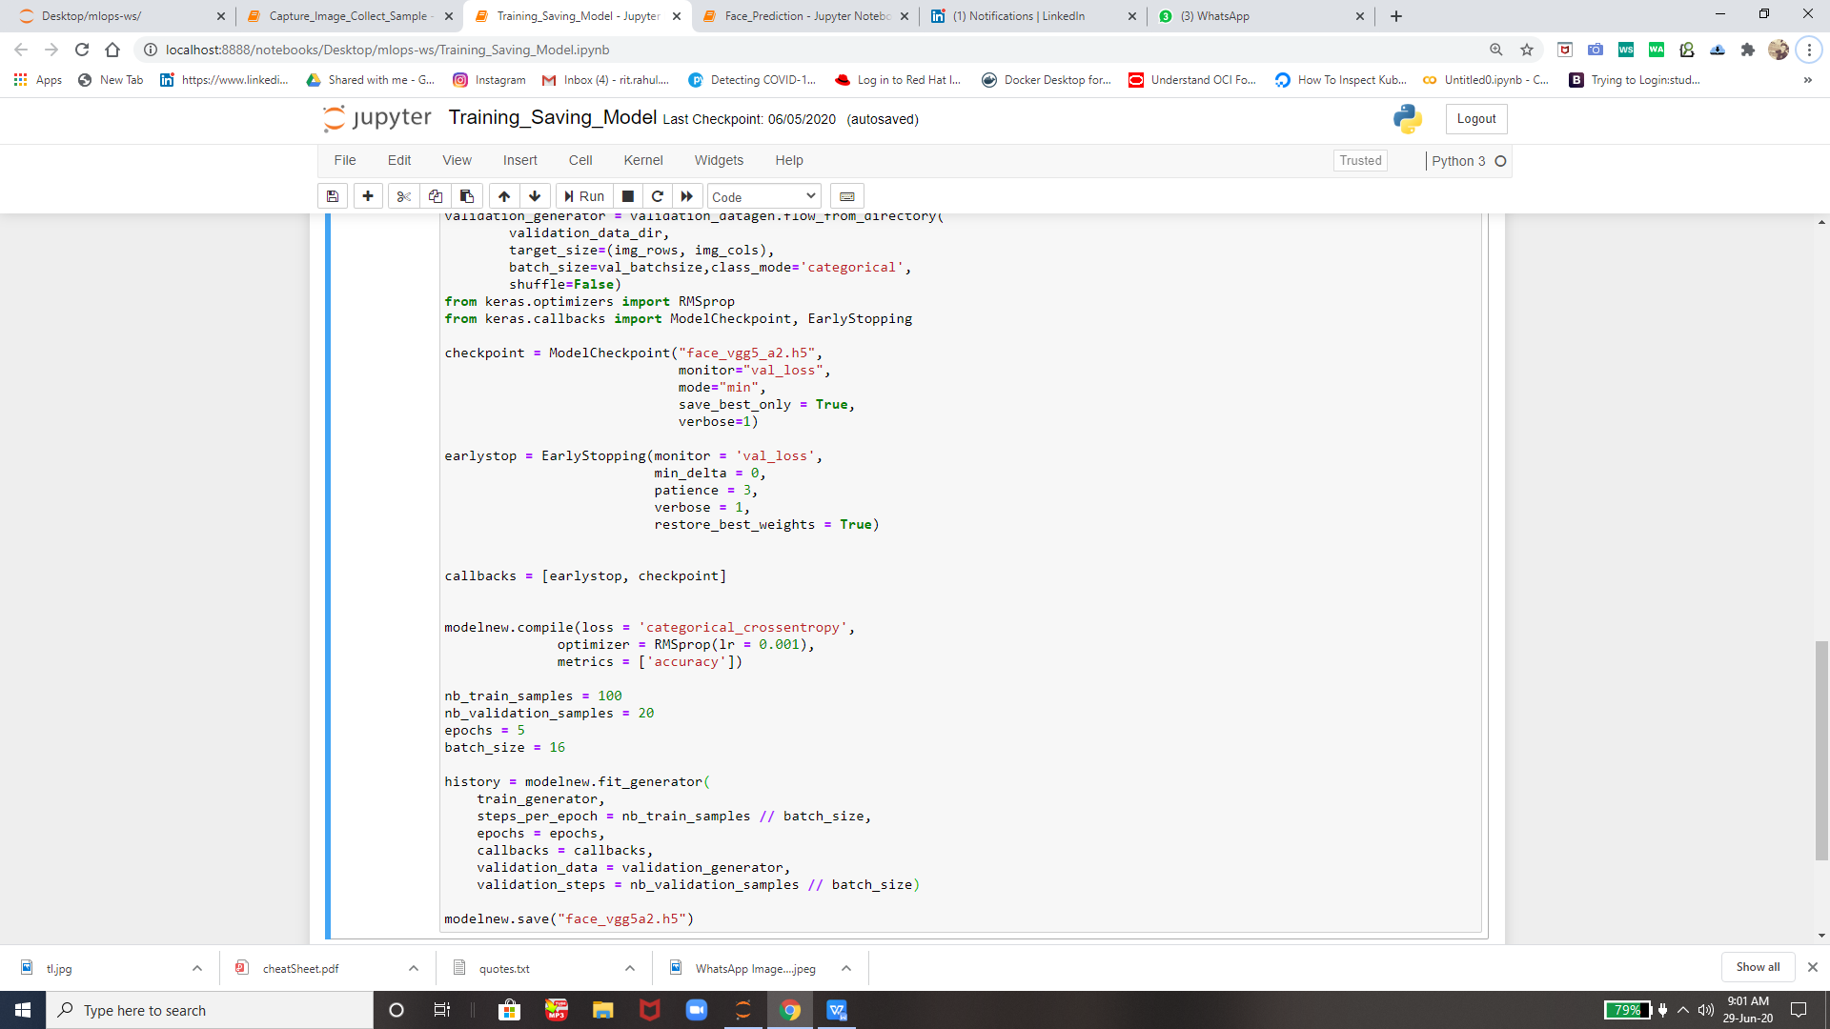

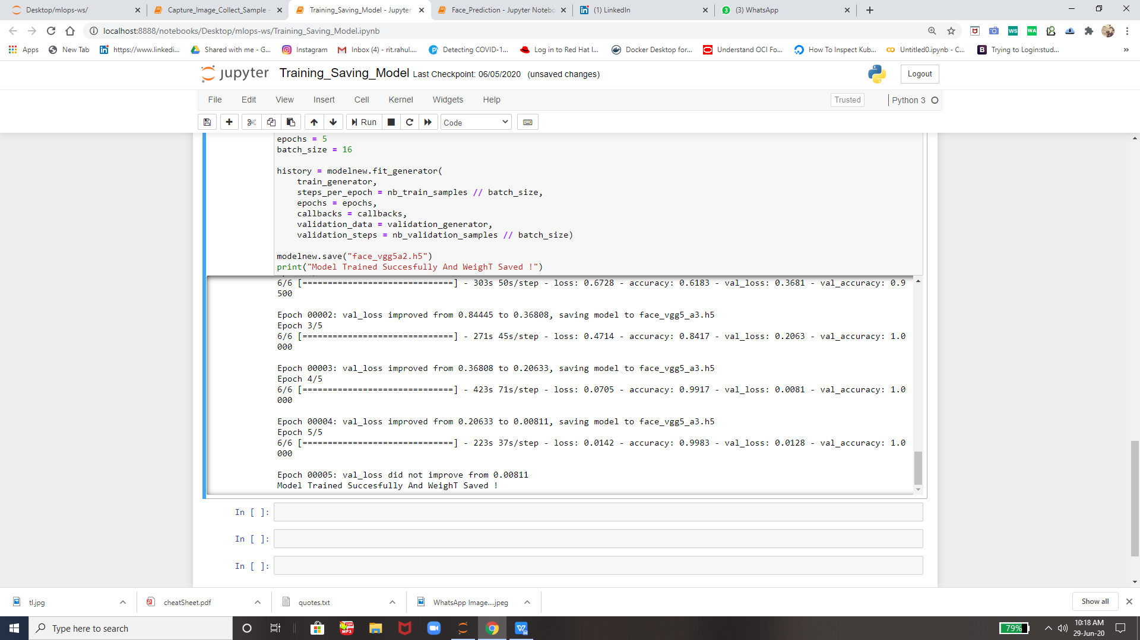

So this save our weigt name as **vgg5a2.h5** in given directory and then we can use this in future

1. **Face\_Prediction.ipynb -** this file will check the weight or we can say that it will collect that weight info and then launch a live video window and there it will detect faces on real time so I m showing u how it will detect faces..

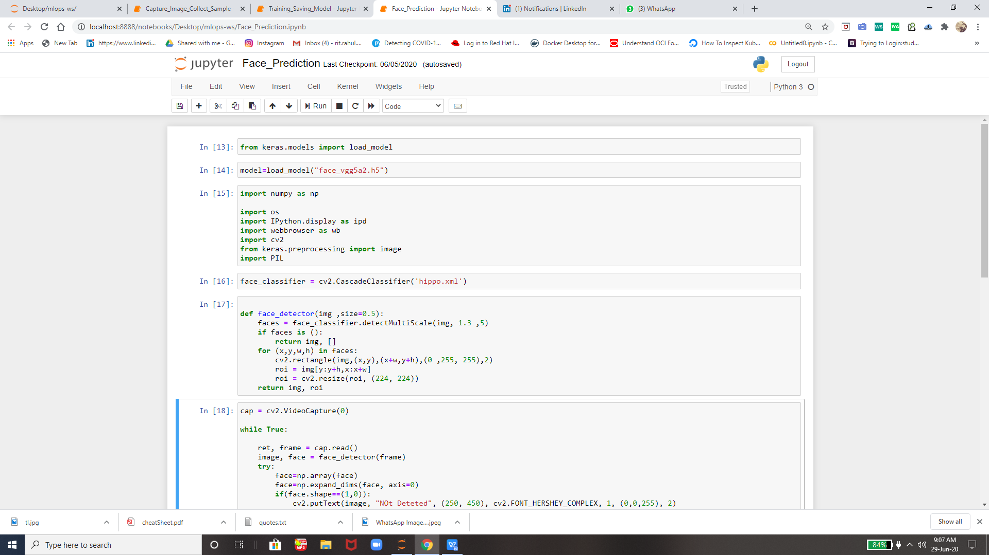

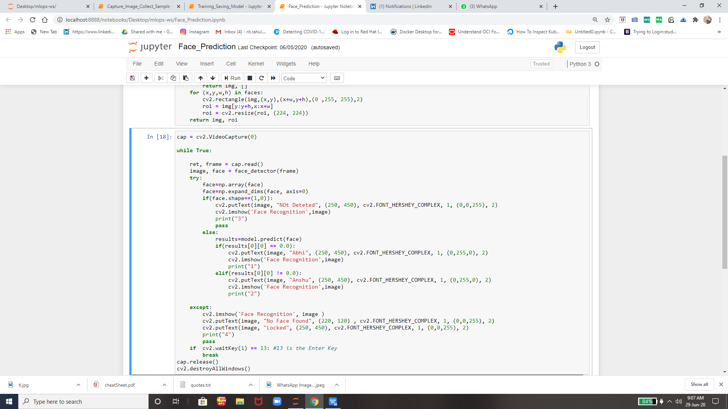

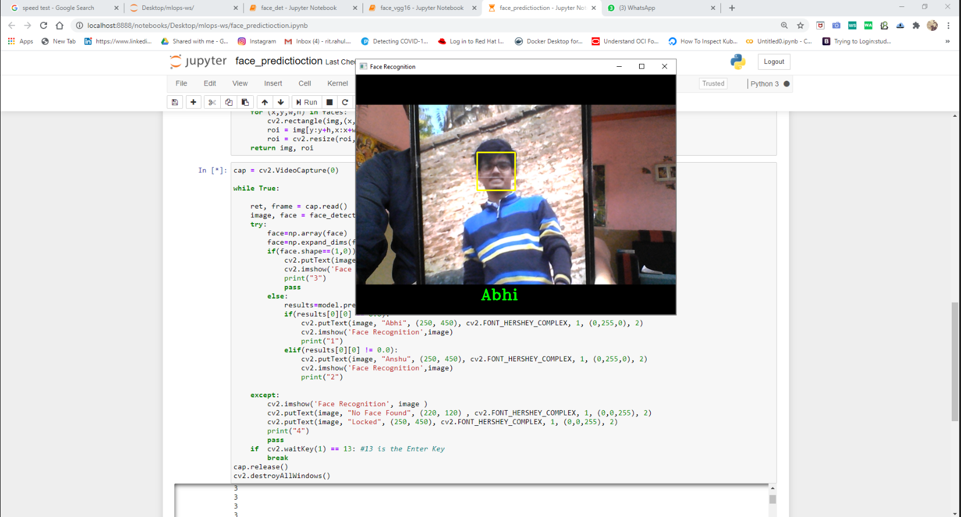

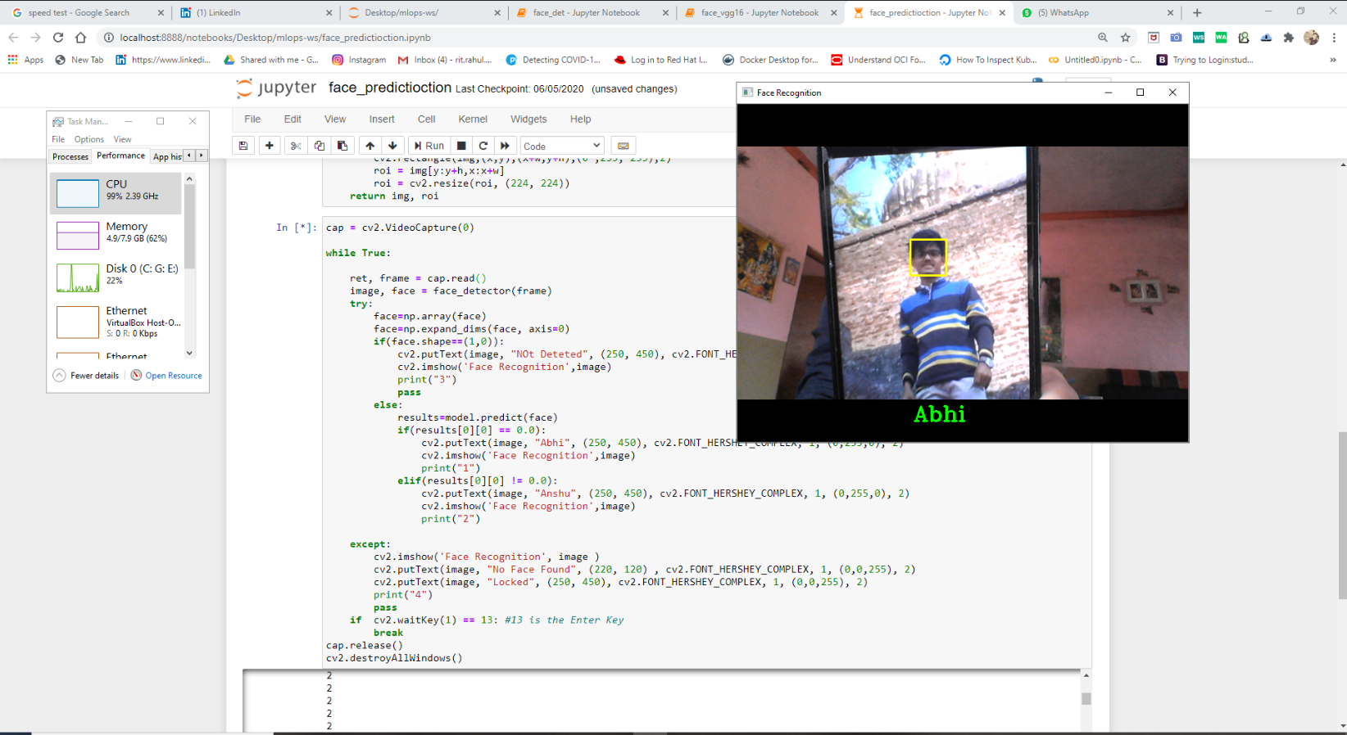

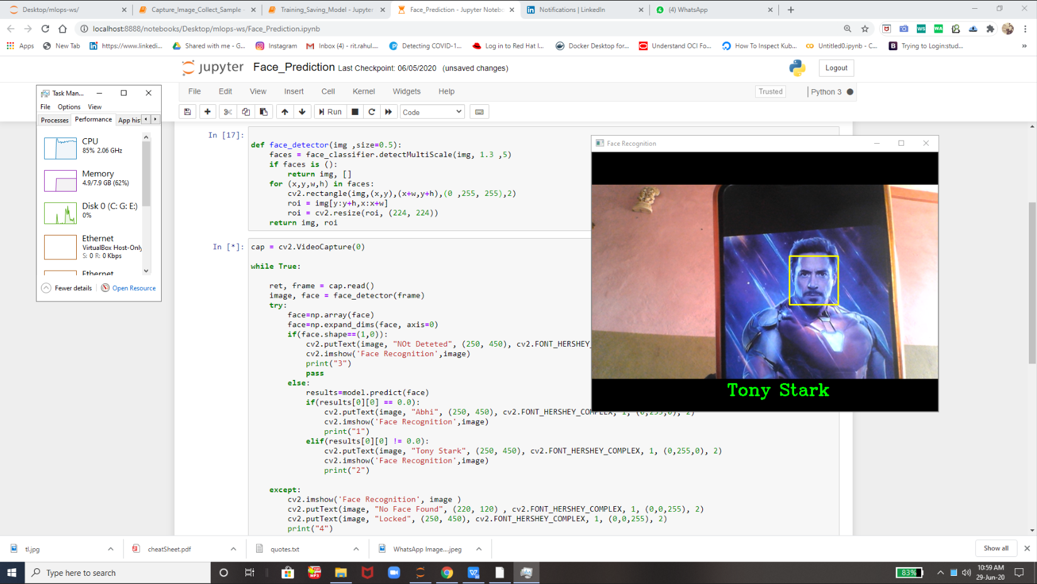

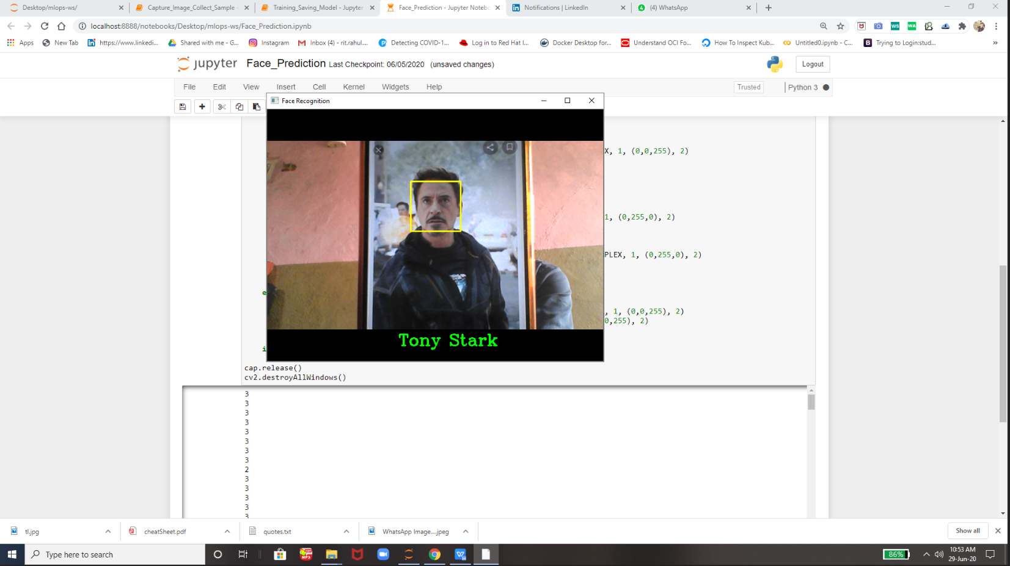

Picture that I used for training and all :-

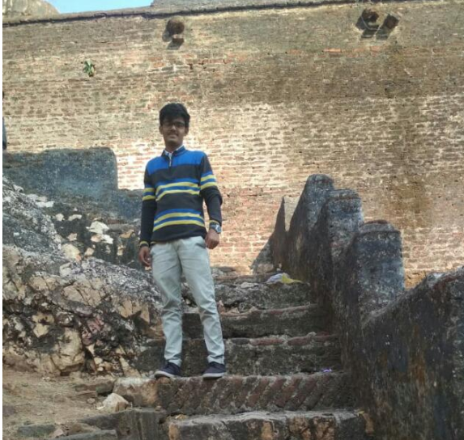

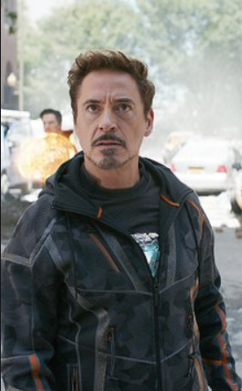

Thats all this this is all about face\_recognition using Transfer Learning All the Codes and files I will upload on GitHub.

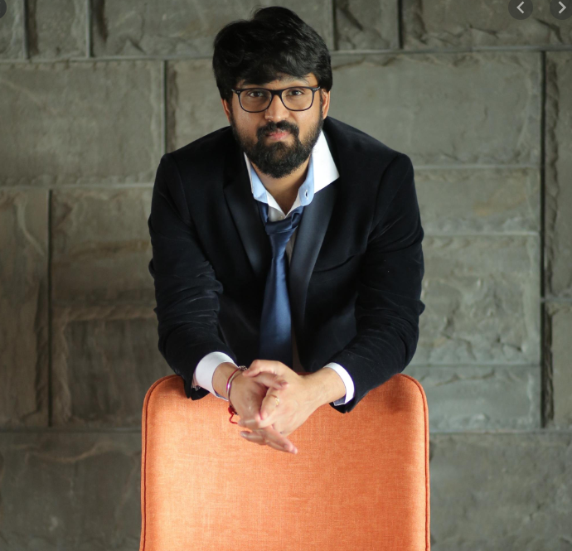

**Thanks you Vimal SIr For Teaching us so much intresting technologies so that today we can create our own projects .**

**Thank you EverOne For Reading .**